EXPERIMENT 11:
Link Jira tasks with Confluence to streamline task tracking and progress monitoring for the Library Management System development.
- Create a new page in Confluence titled &quot;Library Management System Project Overview
- Embed at least 5 Jira issues related to the development of the Library Management System
- Use the Jira macro to display issues with status
- Add a progress bar in the Confluence page to visually track the completion of each embedded Jira task
- Submit a screenshot of the Confluence page showing the embedded Jira tasks and the progress bar.
Step 1: Login
- Open a web browser and navigate to the Jira website.
- Login - https://id.atlassian.com/login
- Sign in to your Jira account using your registered email address and password.
- After successful authentication, access the Jira dashboard to begin the project creation process.
Step 2: Create Jira Issues
- Open the Jira project related to the Library Management System.
- Create the following development tasks:
  - Develop Book Search Functionality
  - Create User Login Page
  - Implement Book Borrowing Module
  - Design Admin Dashboard
  - Test Library Management System
- Verify that all five issues are successfully created in Jira.
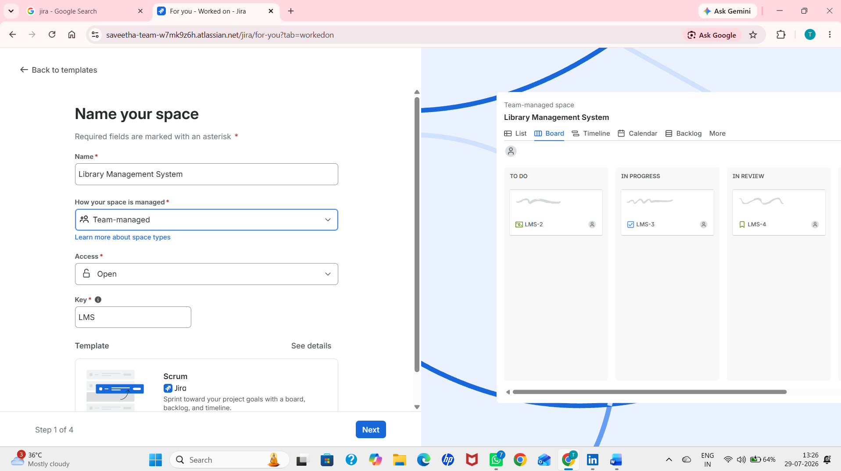
Step 3: Create Jira Issues
- Open the Jira project related to the Library Management System.
- Create the following development tasks:
  - Develop Book Search Functionality
  - Create User Login Page
  - Implement Book Borrowing Module
  - Design Admin Dashboard
  - Test Library Management System
- Verify that all five issues are successfully created in Jira.
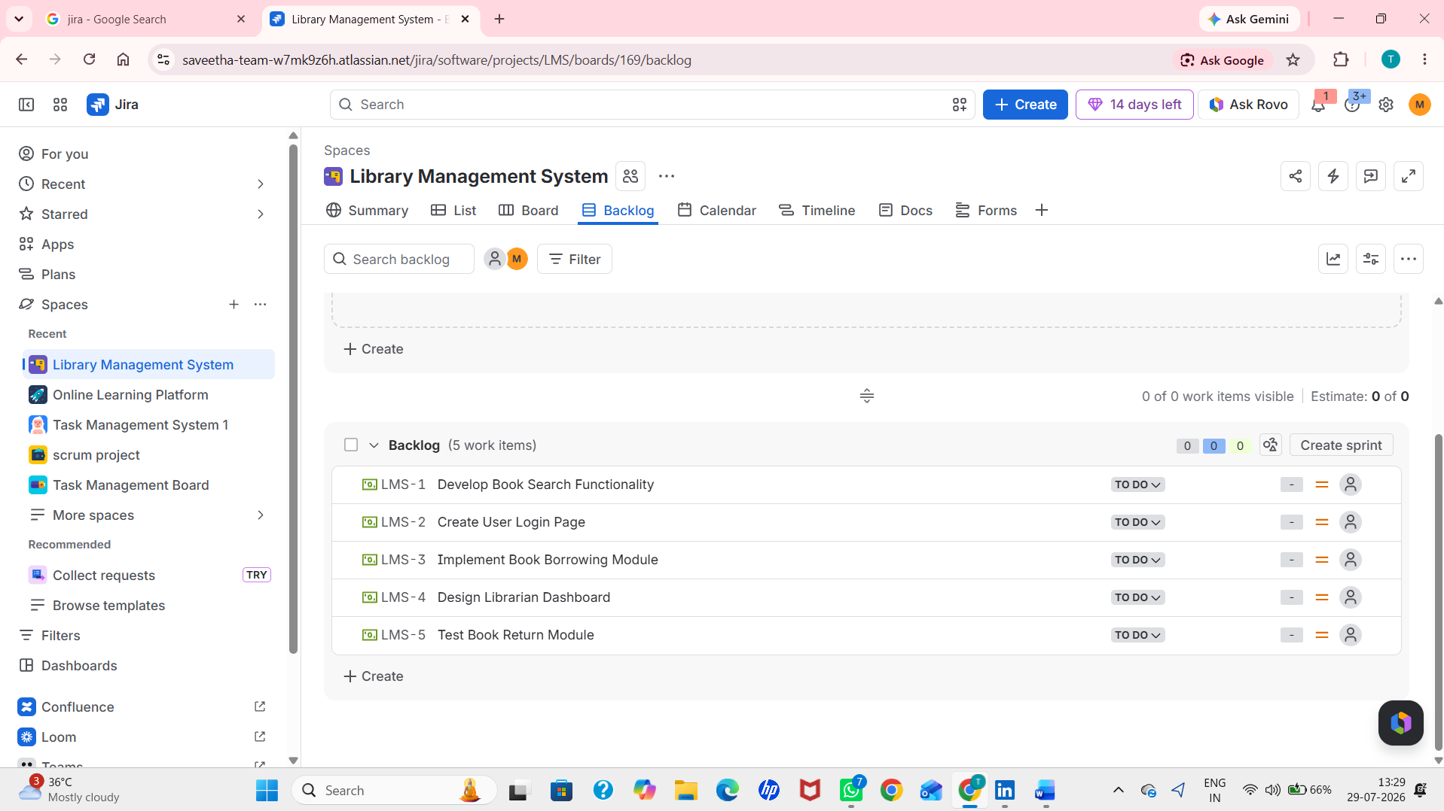
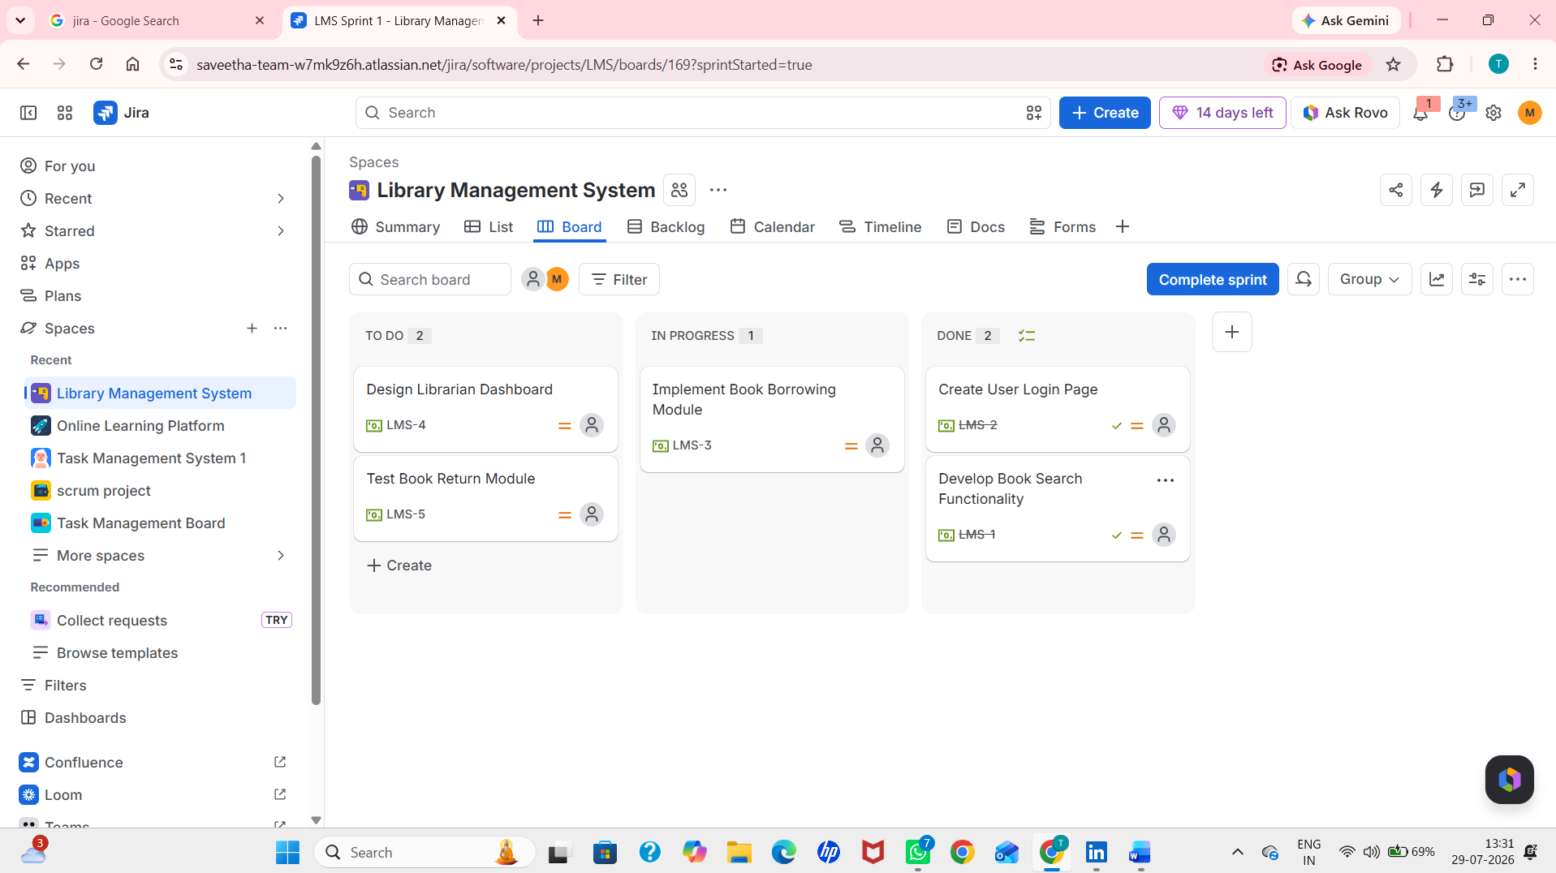
Step 4: Create a New Confluence Page
- Click the Create button to create a new page.
- Enter the page title as Library Management System Project Overview.
- Add a brief description explaining the objectives and development progress of the Library Management System.
- Save the page.
- Verify that all embedded Jira issues are displayed correctly.
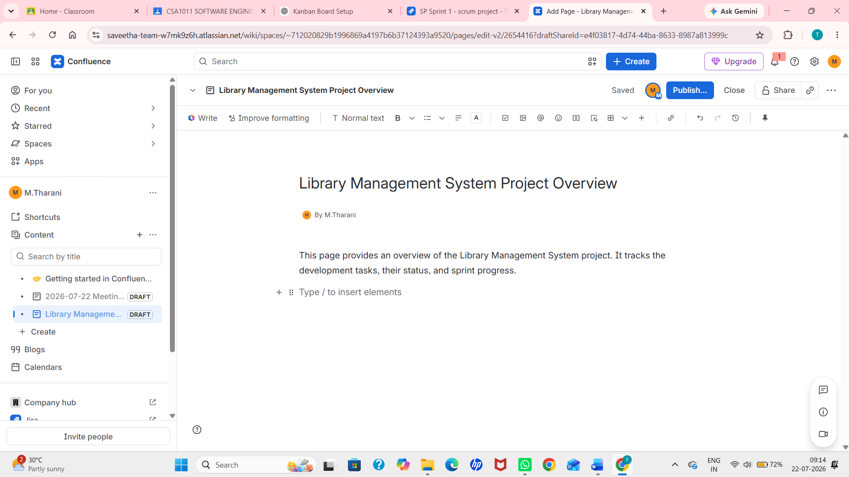
Step 5: Display Task Status
- Configure the Jira macro to display the workflow status of each task.
- Ensure that the task statuses are visible as To Do, In Progress, or Done.
- Verify that the status of each embedded issue is updated automatically based on Jira.
Step 6: Embed Jira Issues in Confluence
- Return to the Library Management System Project Overview page in Confluence.
- Type /jira and select the Jira macro.
- Search for the required Jira issues and insert them into the page.
- Configure the macro to display the issue details, including Issue Key, Summary, Assignee, Priority, and Status.
Step 7: Submit the Output
- Review the Confluence page to ensure that all Jira issues are embedded successfully.
- Verify that the progress bar and task statuses are visible.
- Capture a screenshot of the completed Confluence page showing the embedded Jira tasks and the progress bar. https://saveetha-team-w7mk9z6h.atlassian.net/wiki/x/AYBN
- Submit the screenshot as the final output.
